***Project Title***

**SIM FRANCHISE MANAGEMENT SYSTEM**

# *Description*

It is a sim franchise database management system made in sql, which allocates sim numbers to customers and keeps the record!

Its an easy to use database management system where Sims are being allocated to the customers.

The database is design very technically and followed all steps of a professionally way to saved records .

## *Project Advantages*

* Making sim record easy
* Generate sim revenue
* Making process easier from others
* Get Customer data with systematic way
* All actions record is saved properly
* Totally relational database

### *Project Limitations*

* National database.
* To control record.
* User registered with national Identity.

***ERD DIAGRAM***

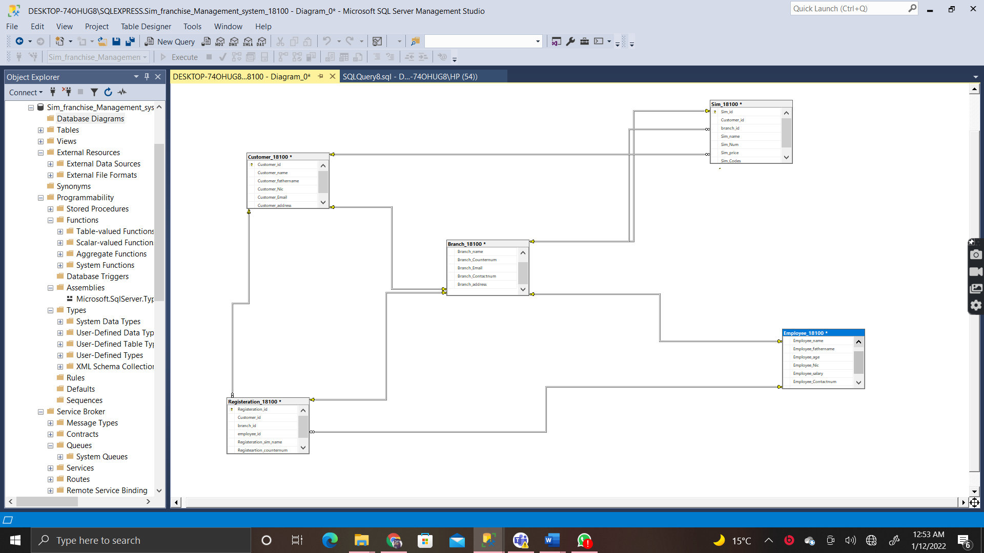

***QURIES***

CREATE DATABASE Sim_franchise_Management_system_18100

CREATE TABLE Customer_18100

(

Customer_id int identity (1,1) primary key,

Customer_name varchar (255),

Customer_fathername varchar (255),

Customer_Nic varchar(25),

Customer_Email varchar (255),

Customer_address varchar (255),

)

Insert into Customer_18100 ( Customer_name,Customer_fathername,Customer_Nic,Customer_Email,Customer_address) values

('shahid','Muhammad khalid','42101-5477873-1','usama.18049@iqra.edu.pk','jauhar'),

('bilal','Muhammad akhtar','42101-5877783-1','bilal.18381@iqra.edu.pk','gulshan'),

('Rizwan','Hafeez baig','42101-6498787-1','rizwan.18048@iqra.edu.pk','malir'),

('Faizan','Amir','42101-7279787-1','faizan.18051@iqra.edu.pk','abbas town'),

('Anas','Mehmood','42101-6098237-1','anas.18052@iqra.edu.pk','malir')

CREATE TABLE Employee_18100

(

Employee_id int identity (1,1) primary key,

Employee_name varchar (255),

Employee_fathername varchar (255),

Employee_age int,

Employee_Nic varchar(25),

Employee_salary int,

Employee_Contactnum varchar (25),

Employee_address varchar (255),

)

Insert into Employee_18100( Employee_name,Employee_fathername,Employee_age,Employee_Nic,Employee_salary,Employee_Contactnum,Employee_address) values

('Rashid','Muhammad shafeeq','18','42101-2572873-1','20000','0343-3333578','surjani'),

('faraz','Muhammad saeed','19','42101-5888883-1','25000','0343-3399552','maymar'),

('arbaz','sultan','20','42101-9798739-1','30000','0311-231158','malir'),

('adil','afzal','21','42101-73119787-1','35000','0300-0060988','malir'),

('shahmer','Maqsood','22','42101-6000237-1','40000','0301-3000078','gulber')

CREATE TABLE Branch_18100

(

Branch_id int identity (1,1) primary key,

Branch_name varchar (255),

Branch_Counternum varchar (255),

Branch_Email varchar (255),

Branch_Contactnum Varchar (25),

Branch_address varchar (255),

)

Insert into Branch_18100( Branch_name,Branch_Counternum,Branch_email,Branch_Contactnum,Branch_address) values

('Zong franchise','6','Zongfran96@gmail.com','0211-6636365','5star Chowarngi'),

('ufone franchise','7','ufonefran81@gmail.com','0211-6646365','gulshan'),

('telenor franchise','8','telenor98fran11@gmail.com','0211-6656365','malir'),

('jazz franchise','9','jazzfran99@gmail.com','0211-6636365','jauhar'),

('warid franchise','10','waridfran90@gmail.com','0211-6636365','malir')

CREATE TABLE Sim_18100

(

Sim_id int identity (1,1) primary key,

Customer_id int not null,

branch_id int not null,

Sim_name varchar (255),

Sim_Num varchar (255),

Sim_price int,

Sim_Codes varchar (255),

)

Insert into Sim_18100( Customer_id,branch_id,Sim_name,Sim_Num,Sim_price,Sim_Codes) values

('5','5','Zong ','0311-2133997','150','*101#'),

('3','2','ufone ','0333-2100937','250','*003#'),

('4','3','telenor ','0343-2133557','275','*2001#'),

('1','4','jazz ','0301-2133007','175','*4001#'),

('2','1','warid ','0300-2133997','300','*501#')

CREATE TABLE Registeration_18100

(

Registeration_id int identity (1,1) primary key,

Customer_id int not null,

branch_id int not null,

employee_id int not null,

Registeration_sim_name varchar (255),

Registeartion_counternum varchar (255),

)

insert into Registeration_18100 (Customer_id,branch_id,employee_id,Registeration_sim_name,Registeartion_counternum) values

('5','5','3','zong','6'),

('3','2','4','ufone','7'),

('4','3','5','telenor','8'),

('1','4','1','jazz','9'),

('2','1','2','warid','10')

---------- FOR SHOW ALL TABLE -------------

select * from Customer_18100

select * from Employee_18100

select * from Branch_18100

select * from Sim_18100

select * from Registeration_18100

------ FOR UPDATE ----------

Update Customer_18100

set Customer_name = 'faizan'

where Customer_id= 1

----- FOR ALTER ADD -------

alter table Employee_18100

add salary decimal (2,1)

-------- FOR ALTER DROP --------

alter table Employee_18100

drop column salary

--------- FOR MAX ------------

select MAX (Employee_age) from Employee_18100

---------- FOR MIN ----------

select Min (Employee_age) from Employee_18100

---------- FOR AVG ----------

select avg (Employee_age) from Employee_18100

----------- FOR SUM ----------

select sum (Sim_price) from Sim_18100

----------- FOR COUNT ---------

select count (Employee_salary)

from Employee_18100;

---------- FOR LIKE -------

Select * From Sim_18100

where Sim_price between 100 and 300

and Sim_name like 'z%'

--------- FOR ORDER --------

select * from Sim_18100

where Sim_name <>'warid'

order by Sim_name

-------- FOR DELETE --------

delete Employee_18100 where Employee_id=2

--------- FOE UNIQUE ---------

Alter table Sim_18100 add unique (Sim_id)

--------- FOR WHERE -------

select Customer_name from Customer_18100 where Customer_address='jauhar';

---------- FOR DISTICNT ----------

select distinct Customer_name,Customer_address from Customer_18100

---------- FOR CREATE LOGIN --------

create login admin1 with password ='1237'

create login assistant with password ='abcd'

--------- FOR CREATE USER ---------

create user admin1 for login admin1

create user assistant for login assistant

--------- FOR GRANT ---------

grant select on customer_18100 to Admin1

grant Insert,Delete on Sim_18100 to assistant

----------- FOR REVOKE ---------

revoke delete on Sim_18100 to assistant

-------- INNER JOIN----------

select Employee_18100.Employee_id,Branch_18100.Branch_name from Employee_18100 inner join Branch_18100 on Employee_18100.Employee_id = Branch_18100.Branch_id

---------- FOR RIGHT JOIN -----------

select Sim_18100.Sim_price,Employee_18100.Employee_name from Sim_18100 right join Employee_18100 on Sim_18100.Sim_id=Employee_18100.Employee_id

-------- LEFT JOIN ----------

select Customer_18100.Customer_name,Sim_18100.Sim_id from Customer_18100

left join Sim_18100 on Customer_18100.Customer_id=Sim_18100.Customer_id

order by Customer_18100.Customer_name

-------- FULL JOIN ---------

select Employee_18100.Employee_name, Branch_18100.Branch_id

from Employee_18100

full OUTER JOIN Branch_18100 ON Employee_18100.Employee_id=Branch_18100.Branch_id

order by Employee_18100.Employee_name;

-- TRIGGER

-------- AFTER INSERT TRIGGERS -----

create trigger tr_insert_tbl_Employee_18100

on Employee_18100

after insert

as

begin

print'New record has been added.'

end

-- insert some data in student table

insert into Employee_18100( Employee_id,Employee_fathername,Employee_age,Employee_Nic,Employee_salary,Employee_Contactnum,Employee_address) values

('Rashid','Muhammad shafeeq','18','42101-2572873-1','20000','0343-3333578','surjani')

-- AFTER TRIGGER FOR DELETE DATA --------

create trigger tr_delete_tbl_Employee_18100

on Employee_18100

after delete

as

begin

print'Something has been deleted.'

end

-- delete some data from student table

delete from Employee_18100 where Employee_id = 3